**EXPRIMENT NO-24**

**CSA1142-OBJECT ORIENTED ANALYSIS AND DESIGN**

**ONLINE STOCK MANAGMENT**

**USE CASE**

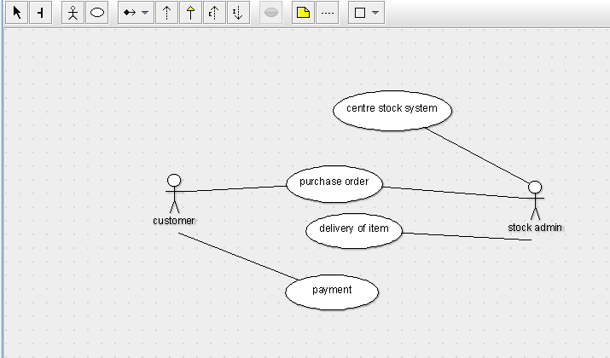

STATE DIAGRAM

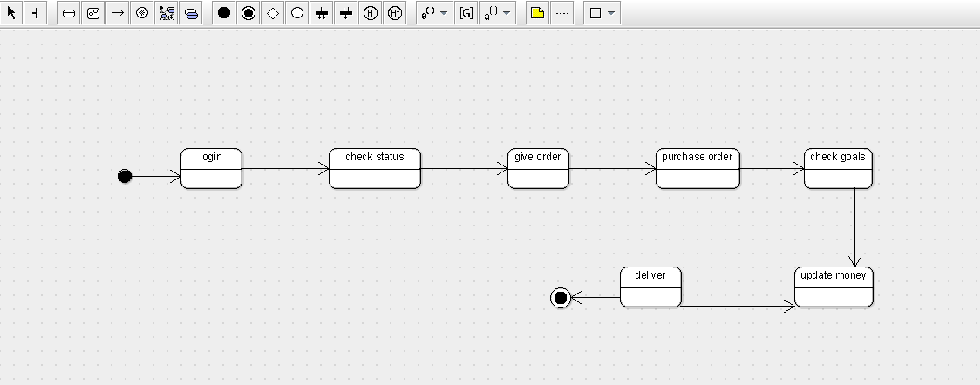

SEQUENCE DIAGRAM

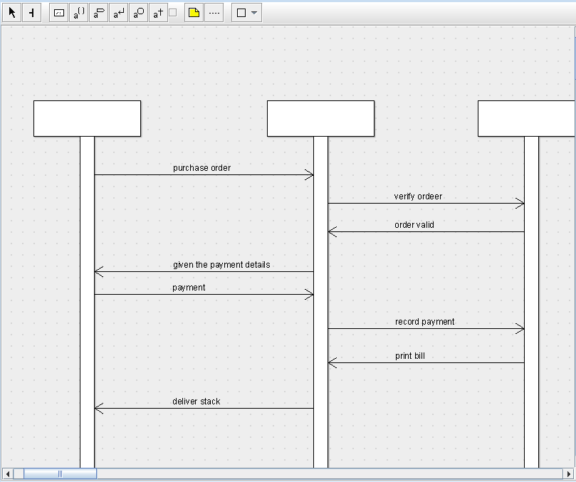

DEPLOYMENT DIAGRAM

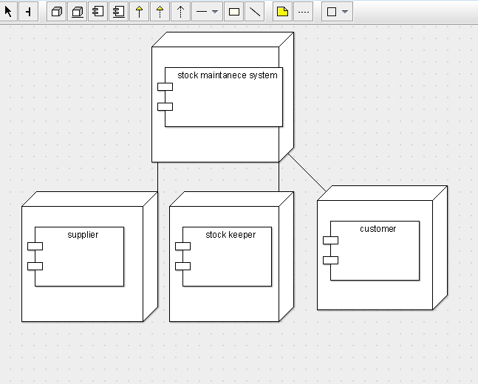

COMPONENT DIAGRAM

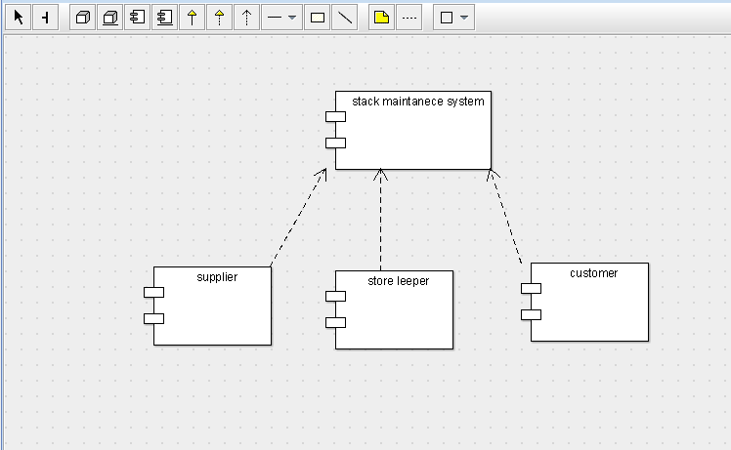

COLLABORATION DIAGRAM

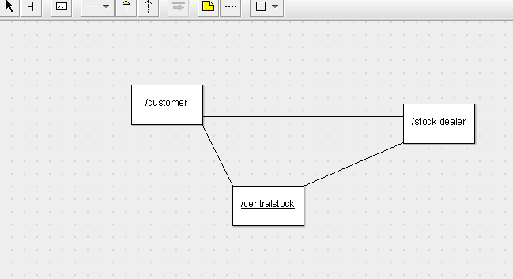

CLASS DIAGRAM

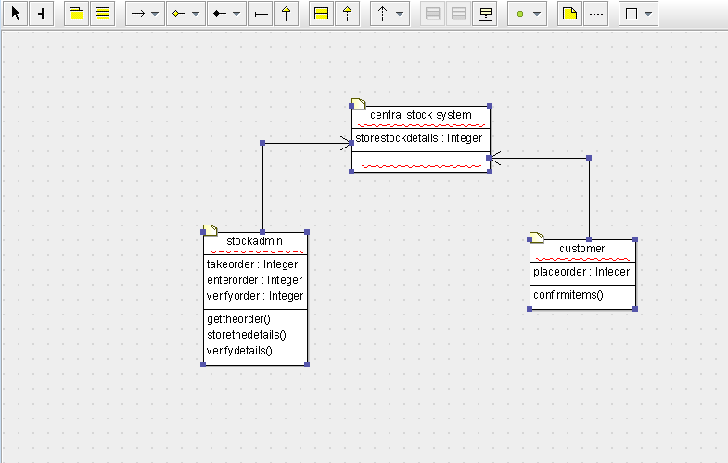

ACTIVITY DIAGRAM

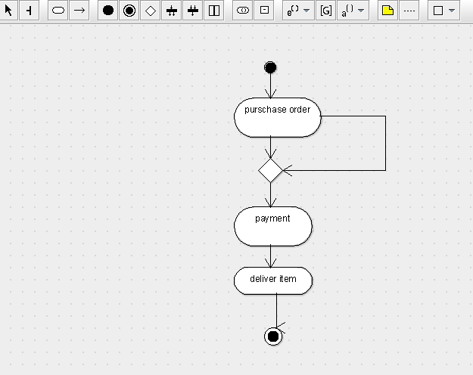

SKELETON CODE:

public class central stock system {

  public Integer storestockdetails;

}

import java.util.Vector;

public class stockadmin {

  public Integer takeorder;

  public Integer enterorder;

  public Integer verifyorder;

    public Vector  mycentral stock system;

  public void gettheorder() {

  }

  public void storethedetails() {

  }

  public void verifydetails() {

  }

}

import java.util.Vector;

public class customer {

  public Integer placeorder;

    public Vector  mycentral stock system;

  public void confirmitems() {

  }

}